**CODE**

**TimeServer.java**

import java.io.*;

import java.net.*;

import java.text.SimpleDateFormat;

import java.util.*;

class TimeServer{

public static void main(String args[])throws Exception{

ServerSocket ss=new ServerSocket(3333);

Socket s=ss.accept();

DataInputStream din=new DataInputStream(s.getInputStream());

DataOutputStream dout=new DataOutputStream(s.getOutputStream());

BufferedReader br=new BufferedReader(new InputStreamReader(System.in));

String str="",str2="";

while(!str.equals("stop")){

str=din.readUTF();

String currentTime = getCurrentTime();

System.out.println("client says: "+str+" "+currentTime);

str2=br.readLine();

dout.writeUTF(str2);

dout.flush();

}

din.close();

s.close();

ss.close();

}

private static String getCurrentTime() {

Date date = new Date();

SimpleDateFormat dateFormat = new SimpleDateFormat("yyyy-MM-dd HH:mm:ss");

return dateFormat.format(date);

}

**OUTPUT**

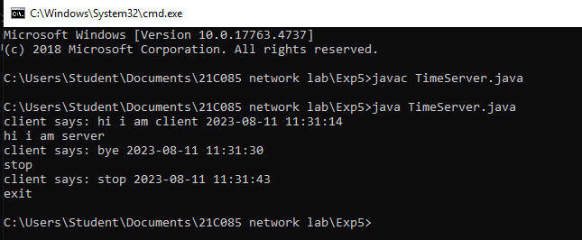

**CODE**

**TimeClient.java**

import java.net.*;

import java.io.*;

import java.text.SimpleDateFormat;

import java.util.*;

class TimeClient{

public static void main(String args[])throws Exception{

Socket s=new Socket("localhost",3333);

DataInputStream din=new DataInputStream(s.getInputStream());

DataOutputStream dout=new DataOutputStream(s.getOutputStream());

BufferedReader br=new BufferedReader(new InputStreamReader(System.in));

String str="",str2="";

while(!str.equals("stop")){

str=br.readLine();

dout.writeUTF(str);

dout.flush();

str2=din.readUTF();

String currentTime = getCurrentTime();

System.out.println("Server says: "+str2+" "+currentTime);

}

dout.close();

s.close();

}

private static String getCurrentTime() {

Date date = new Date();

SimpleDateFormat dateFormat = new SimpleDateFormat("yyyy-MM-dd HH:mm:ss");

return dateFormat.format(date);

}

}

OUTPUT